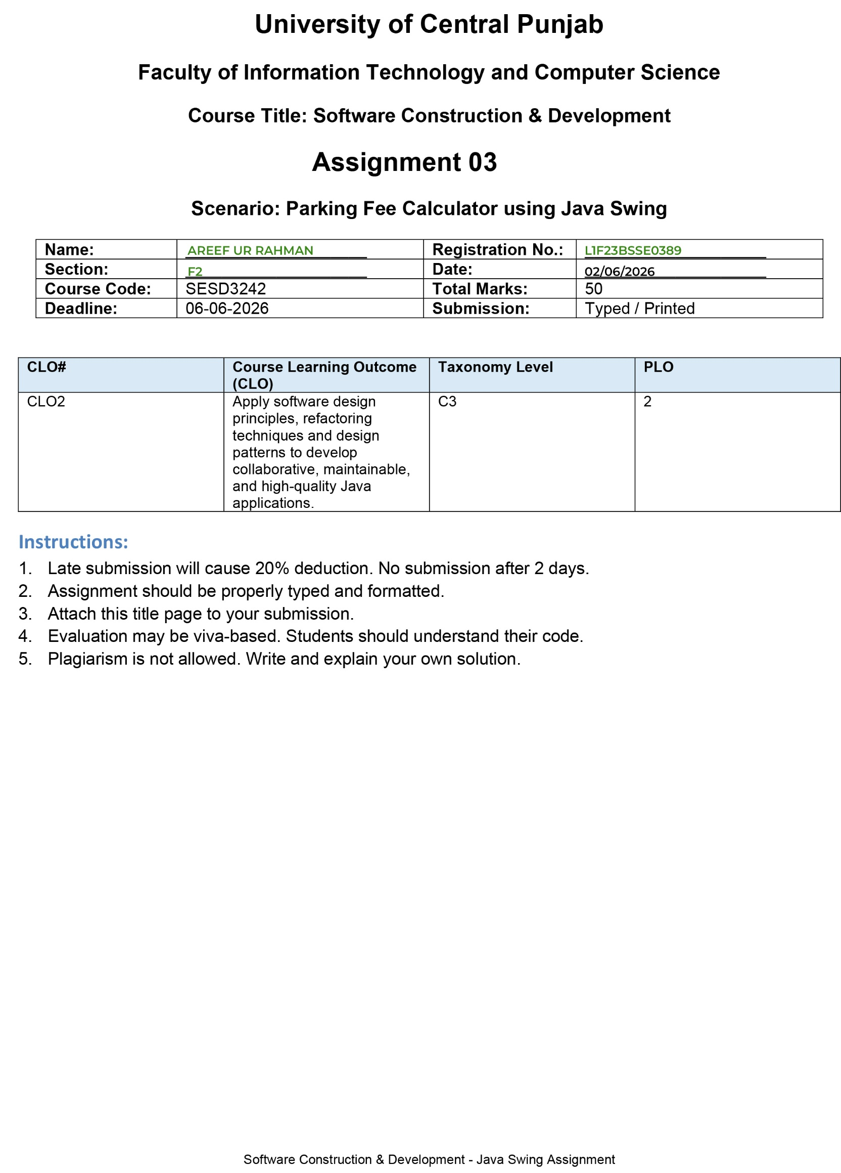
ParkingFeeCalculator.java:
import javax.swing.*;
import java.awt.*;
import java.awt.event.*;

public class ParkingFeeCalculator extends JFrame implements ActionListener {

private JTextField txtHours;
private JTextField txtFee;

private JButton btnGenerate;
private JButton btnReset;

private ParkingFeeService feeService;

public ParkingFeeCalculator() {

feeService = new ParkingFeeService(
new RegularFeeStrategy());

initializeUI();
}

private void initializeUI() {

setTitle("Parking Fee Calculator");
setSize(500, 250);
setLocationRelativeTo(null);
setDefaultCloseOperation(JFrame.EXIT_ON_CLOSE);

JPanel panel = new JPanel(new GridLayout(4, 2, 10, 10));

JLabel lblHours = new JLabel("Enter Parking Hours:");
JLabel lblFee = new JLabel("Total Fee (Rs.):");

txtHours = new JTextField();
txtFee = new JTextField();

txtFee.setEditable(false);

btnGenerate = new JButton("Generate Fee");
btnReset = new JButton("Reset");

btnGenerate.addActionListener(this);
btnReset.addActionListener(this);

panel.setBorder(
BorderFactory.createEmptyBorder(20, 20, 20, 20));

panel.add(lblHours);
panel.add(txtHours);

panel.add(lblFee);
panel.add(txtFee);

panel.add(btnGenerate);
panel.add(btnReset);

add(panel);

setVisible(true);
}

@Override
public void actionPerformed(ActionEvent e) {

if (e.getSource() == btnGenerate) {
generateFee();
}

if (e.getSource() == btnReset) {
clearFields();
}
}

private void generateFee() {

try {

String input = txtHours.getText().trim();

// Empty Field Validation
if (input.isEmpty()) {

JOptionPane.showMessageDialog(
this,
"Parking hours cannot be empty!",
"Input Error",
JOptionPane.ERROR_MESSAGE);

return;
}

int hours = Integer.parseInt(input);

if (hours < 0) {

JOptionPane.showMessageDialog(
this,
"Hours cannot be negative!",
"Input Error",
JOptionPane.ERROR_MESSAGE);

return;
}

double totalFee =
feeService.calculateParkingFee(hours);

txtFee.setText(
String.format("%.2f", totalFee));

}

catch (NumberFormatException ex) {

JOptionPane.showMessageDialog(
this,
"Please enter a valid numeric value!",
"Invalid Input",
JOptionPane.ERROR_MESSAGE);
}

finally {

JOptionPane.showMessageDialog(
this,
"Operation Completed.");
}
}

private void clearFields() {

txtHours.setText("");
txtFee.setText("");

JOptionPane.showMessageDialog(
this,
"Fields Cleared Successfully.");
}

public static void main(String[] args) {

SwingUtilities.invokeLater(() ->
new ParkingFeeCalculator());
}
}

ParkingFeeService.java:
public class ParkingFeeService {

private FeeStrategy feeStrategy;

public ParkingFeeService(FeeStrategy feeStrategy) {
this.feeStrategy = feeStrategy;
}

public double calculateParkingFee(int hours) {
return feeStrategy.calculate(hours);
}
}

FeeStrategy.java:
public interface FeeStrategy {

double calculate(int hours);

}

RegularFeeStrategy.java:
public class RegularFeeStrategy implements FeeStrategy {

private static final double RATE_UP_TO_3_HOURS = 50.0;
private static final double RATE_ABOVE_3_HOURS = 80.0;

@Override
public double calculate(int hours) {

double rate = (hours <= 3)
? RATE_UP_TO_3_HOURS
: RATE_ABOVE_3_HOURS;

return hours * rate;
}
}

Screenshots:
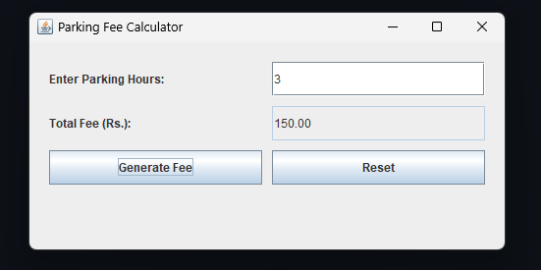

Finally Block:
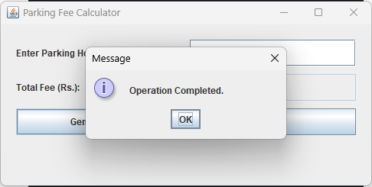

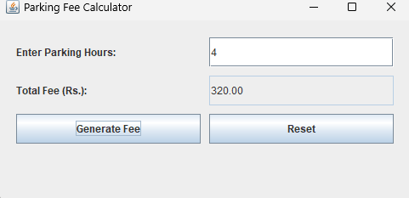

Rest Button:
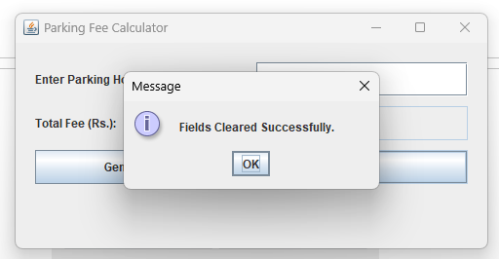

Exception Handling:
